Part 4

Start the system

Start spark_cluster
Open Docker, and start hadoop_cluster.

Open the hadoop1’s terminal
Open the Windows’ Command Prompt, and execute the command:
docker exec -it hadoop1 bash

Start the system
./start

Partition Large DataFrame

What is PySpark Partition?
PySpark partition is a way to split a large dataset into smaller datasets based on one or more partition keys. When you create a DataFrame from a file/table, based on certain parameters PySpark creates the DataFrame with a certain number of partitions in memory. Transformations on partitioned data run faster as they execute transformations parallelly for each partition.
PySpark supports partition in two ways; partition in memory (DataFrame) and partition on the disk (File system).

Partition in memory
You can partition or repartition the DataFrame by calling repartition() or coalesce() transformations.

Partition on disk
While writing the PySpark DataFrame back to disk, you can choose how to partition the data based on columns using partitionBy() of pyspark.sql.DataFrameWriter.

Partition Advantages
- Fast access to the data
- Provides the ability to perform an operation on a smaller dataset

Creating DataFrame
df=spark.read.option("header",True) \
.csv("/data/simple-zipcodes.csv")
df.printSchema()

partitionBy()
In PySpark, the partitionBy() transformation is used to partition data in an RDD or DataFrame based on the specified partitioner. It is typically applied after certain operations such as groupBy() or join() to control the distribution of data across partitions.

Syntax:
partitionBy(self, *cols)
When you write PySpark DataFrame to disk by calling partitionBy(), PySpark splits the records based on the partition column and stores each partition data into a sub-directory.
For example,
df.write.option("header",True) \
.partitionBy("state") \
.mode("overwrite") \
.csv("/data/zipcodes-state")
Note: When writing the data as partitions, PySpark eliminates the partition column on the data file and adds the partition column and value to the folder name, saving some storage space.
Check the result:
ll /data/zipcodes-state/
ll /data/zipcodes-state/state=AL
cat /data/zipcodes-state/state=AL/*

partitionBy() Multiple Columns
You can also create partitions on multiple columns using PySpark partitionBy().
df.write.option("header",True) \
.partitionBy("state","city") \
.mode("overwrite") \
.csv("/data/zipcodes-state-city")
Check the result:
ll /data/zipcodes-state-city/
ll /data/zipcodes-state-city/state=AL
ll /data/zipcodes-state-city/state=AL/city=SPRINGVILLE
cat /data/zipcodes-state-city/state=AL/city=SPRINGVILLE/*

Using repartition() and partitionBy() together
The repartition() is used to increase or decrease the number of partitions in memory and when you use it with partitionBy(), it further breaks down into multiple partitions based on column data.
df.repartition(2) \
.write.option("header",True) \
.partitionBy("state") \
.mode("overwrite") \
.csv("/data/zipcodes-state-more")
Check the result:
ll /data/zipcodes-state-more
ll /data/zipcodes-state-more/state=AL

Control Number of Records per Partition File
Use option maxRecordsPerFile if you want to control the number of records for each partition. This is particularly helpful when your data is skewed (Having some partitions with very low records and other partitions with a high number of records).
df.write.option("header",True) \
.option("maxRecordsPerFile", 2) \
.partitionBy("state") \
.mode("overwrite") \
.csv("/data/zipcodes-state")
The above example creates multiple part files for each state and each part file contains just 2 records.
Check the result:
ll /data/zipcodes-state/
ll /data/zipcodes-state/state=AL
cat /data/zipcodes-state/state=AL/part*c000.csv
cat /data/zipcodes-state/state=AL/part*c001.csv

Read a Specific Partition
Reads are much faster on partitioned data. This code snippet retrieves the data from a specific partition "state=AL and city=SPRINGVILLE". Here, It just reads the data from that specific folder instead of scanning a whole file (when not partitioned).
df=spark.read.option("header",True) \
.csv("/data/zipcodes-state-city/state=AL/city=SPRINGVILLE")
df.printSchema()
df.show()
Note: While reading specific Partition data into DataFrame, it does not keep the partition columns on DataFrame; hence, you printSchema() and DataFrame is missing state and city columns.

Read a Specific Partition using Spark SQL
df = spark.read.option("header",True) \
.csv("/data/zipcodes-state-city")
df.createOrReplaceTempView("ZIPCODE")
Select state=’AL’:
spark.sql("select * from ZIPCODE where state='AL'").show()
Select state=’AL’ and city=’ SPRINGVILLE’:
spark.sql("select * from ZIPCODE where state='AL' and city = 'SPRINGVILLE'").show()
The execution of this query is also significantly faster than the query without partition. It filters the data first on state and then applies filters to the city column without scanning the entire dataset.

Remove output directories
rm -r /data/zipcodes-*

Spark Streaming

What is Spark Streaming?
Spark Streaming is a scalable, high-throughput, fault-tolerant streaming processing system that supports both batch and streaming workloads. It is an extension of the core Spark API to process real-time data from sources like TCP socket, Kafka, Flume, and Amazon Kinesis to name it few. This processed data can be pushed to databases, Kafka, live dashboards e.t.c
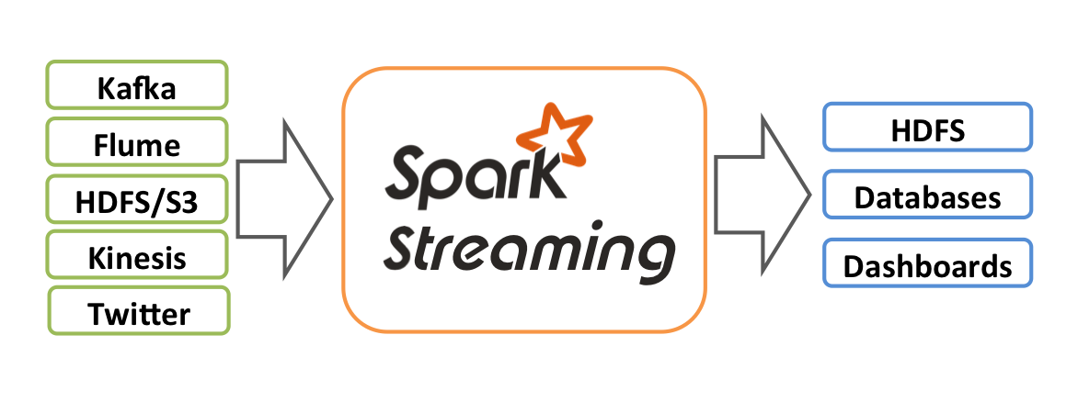

Spark Streaming data from TCP Socket
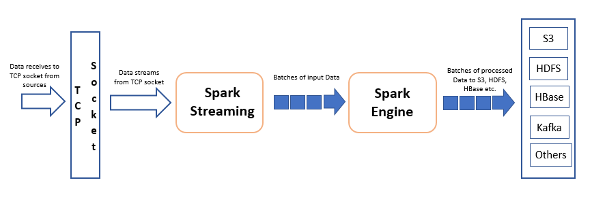
Using Spark streaming we will see a working example of how to read data from TCP Socket, process it and write output to console. Spark uses readStream() to read and writeStream() to write streaming DataFrame or Dataset. The below-explained example does the word count on streaming data and outputs the result to console.
Use readStream.format("socket") from Spark session object to read data from the socket and provide options host and port where you want to stream data from.
df = spark.readStream
.format("socket")
.option("host","localhost")
.option("port","9090")
.load()
df.printSchema()
Spark reads the data from socket and represents it in a “value” column of DataFrame. df.printSchema() outputs

Netcat Installation
Netcat is a networking utility for reading from and writing to network connections using TCP or UDP.
apt install netcat

Run the example in PySpark

Run data stream processing code in PySpark
First, we import StreamingContext, which is the main entry point for all streaming functionality. We create a StreamingContext with batch interval of 1 second.
from pyspark.streaming import StreamingContext
ssc = StreamingContext(sc, 1)
Using this context, we can create a DStream (discretized stream) that represents streaming data from a TCP source, specified as hostname (e.g. localhost) and port (e.g. 9999).
lines = ssc.socketTextStream("localhost", 9999)
This lines DStream represents the stream of data that will be received from the data server. Each record in this DStream is a line of text. Next, we want to split each line of text by space into words.
words = lines.flatMap(lambda line: line.split(" "))
Count each word in each batch:
pairs = words.map(lambda word: (word, 1))
wordCounts = pairs.reduceByKey(lambda x, y: x + y)
Print the first ten elements of each RDD generated in this DStream to the console:
wordCounts.pprint()
Note that when these lines are executed, Spark Streaming only sets up the computation it will perform when it is started, and no real processing has started yet. To start the processing after all the transformations have been setup, we finally call”
ssc.start() # Start the computation
ssc.awaitTermination() # Wait for the computation to terminate

Run Netcat in another terminal
Run Netcat as a data server and enter any text:
nc -lk 9999
Note:
- To end the Netcat, press Ctrl-C.
- To end the processing code, press Ctrl-C then type exit(), Enter.

Sending files to Netcat
Send each line in the file to Netcat after 0.2 seconds:
while read -r line ; do echo "$line"; sleep 0.2; done < /data/alice-in-wonderland.txt | nc -l 9999 -q 1

Run the example in IDE

Run the data processing code in the IDE
from pyspark import SparkContext
from pyspark.sql import SparkSession
from pyspark.streaming import StreamingContext

spark = SparkSession.builder.appName('Example').getOrCreate()
sc = spark.sparkContext

# Create a StreamingContext with batch interval of 1 second
ssc = StreamingContext(sc, 1)
lines = ssc.socketTextStream("localhost", 9999)
words = lines.flatMap(lambda line: line.split(" "))

# Count each word in each batch
pairs = words.map(lambda word: (word, 1))
wordCounts = pairs.reduceByKey(lambda x, y: x + y)

# Print the first ten elements of each RDD generated in this DStream to the console
wordCounts.pprint()

ssc.start() # Start the computation
ssc.awaitTermination() # Wait for the computation to terminate

Run Netcat
Run Netcat as a data server and enter any text:
nc -lk 9999

Stop the system

Stop the system
./stop

Exit from the hadoop1’s terminal
exit

Stop the spark_cluster
Open Docker, and stop hadoop_cluster.

